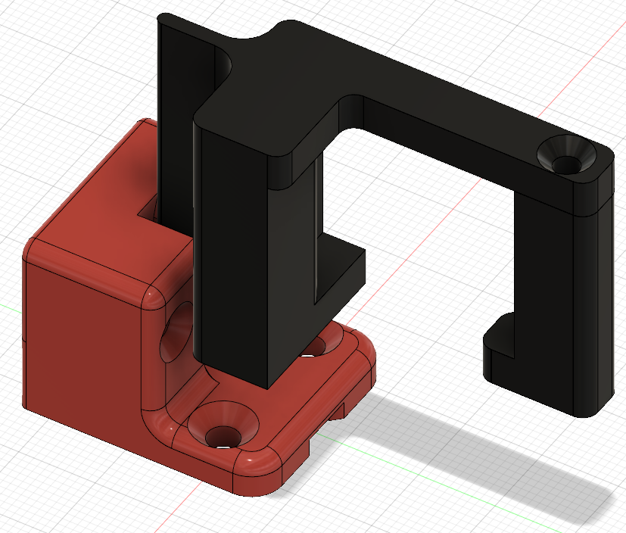

ProMega Optical Z End Stop

# Introduction

In a CoreXY printer setup, the Z end stop is usually located at the bottom of the printer which equates to the maximum Z extent. Due to this, having an accurate and repeatable height measurement from that end stop to the nozzle is very important. In the existing Z end stop design, the bed rests on the actual mechanical switch and the switch is not mechanically fixed in the Z direction, i.e. it can have a little bit of play. Even if the amount of possible Z movement of the switch is only 0.5mm, that is by far too much, causing issues with repeatable Z zero position after homing the Z axis.

The Optical Z End Stop design solves those issues and yields perfect Z zero position every time.

# Bill of Materials

The following parts are needed:

* Optical Switch, here are two links, they are all the same model, just different quantities. This should give you an idea of the model used. There are other optical switches but they might not fit the 3D printed case below.  
   <https://www.amazon.com/Solu-Optical-Endstop-Printer-Makerbot/dp/B00V2QPU4M/ref=sr_1_fkmr0_2?ie=UTF8&qid=1532188647&sr=8-2-fkmr0&keywords=optical+switch+sensor+end+stop>  
   <https://www.amazon.com/HONG111-Optical-Endstop-Control-Printer/dp/B071KBC3P8/ref=pd_sbs_60_5?_encoding=UTF8&pd_rd_i=B071KBC3P8&pd_rd_r=ZFVDCVKD368GX9JMT1H4&pd_rd_w=aIaxL&pd_rd_wg=nmrnQ&psc=1&refRID=ZFVDCVKD368GX9JMT1H4>
* 3D Printed Optical End Stop Housing  
   Optical Z Endstop Holder.stl
* 3D Printed Slider Fin  
   Main Fin.stl
* 3D Printed Counter Mount  
   Counter Mount.stl
* 3 x M3 x 12mm countersunk screw
* 2 x M3 nut
* 2 x Small Cable Tie
* 1 Dupont 3 port plug (optional)  
   <https://www.amazon.com/620-PCS-2-54mm-Pitch-JST/dp/B07BCYTL7R/ref=sr_1_1_sspa?ie=UTF8&qid=1532189524&sr=8-1-spons&keywords=dupont+plug&psc=1>
* 1 M3 Threaded Brass Insert (something like the link below)  
   <https://www.amazon.com/a16041800ux0827-Cylindrical-Knurled-Threaded-Embedded/dp/B01IZ1RN0A/ref=pd_sim_60_4?_encoding=UTF8&pd_rd_i=B01IZ1RN0A&pd_rd_r=DH9H4ZE7YE1XZ3Y53WRG&pd_rd_w=yoUrX&pd_rd_wg=PvLMJ&psc=1&refRID=DH9H4ZE7YE1XZ3Y53WRG>

# Assembly

## Optical End Stop

Make sure that the optical switch is perfectly flat against the PCB. If necessary, heat the pins up with a soldering iron and press the switch on the PCB until it is flat. Pay attention not to ruin the solder pads on the PCB.

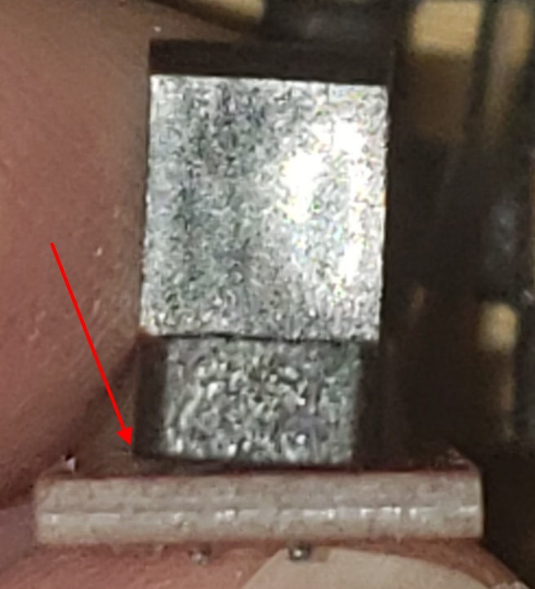 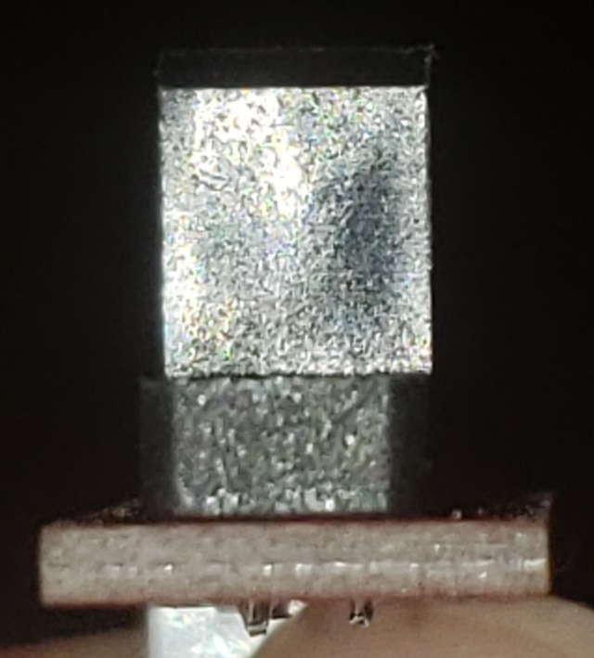

Once the 3D printed parts are done, insert the optical switch into the housing and fix it in place with the two screws and nuts.

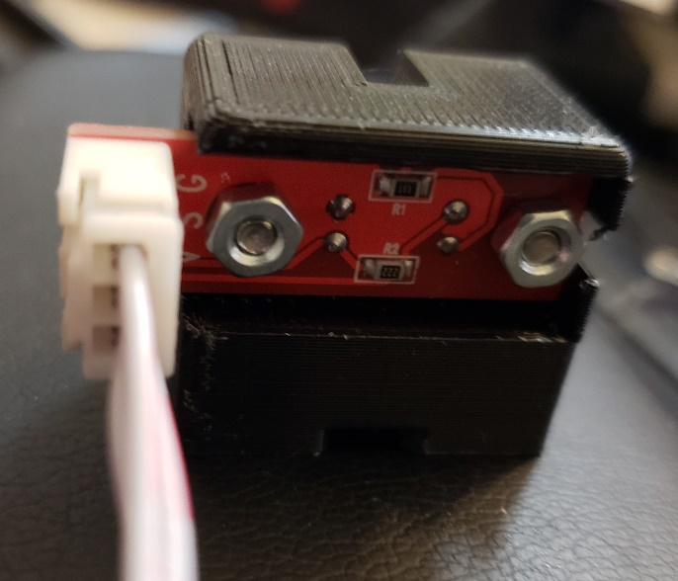 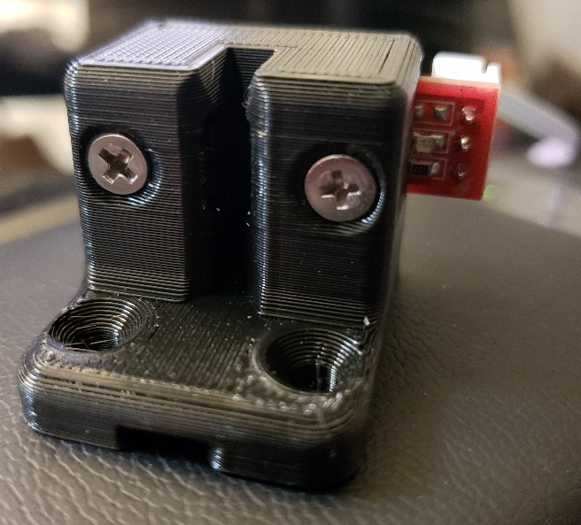

If you chose to get the 3 port Dupont plug, take the black single plugs off the sensor cable and put them in the correct order into the 3 port plug. Pay attention that the 3.3V and signal lines need to cross over.

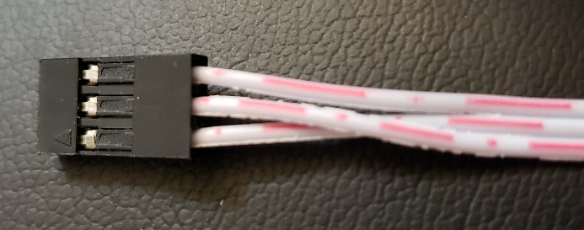

The order from top to bottom in the previous picture is:

1. GND
2. 3.3V
3. Signal

## Installing the Fin

Heat up your soldering iron and melt the threaded brass insert into the hole of the counter mount. Make sure that the insert is perfectly straight. Let the part cool down until no longer hot to the touch.

With the printer running, move the bed to about half way up. Slide the main fin onto the back right Z slider. Make sure it is nice and snug on it. Use the M3 screw to screw the counter mount onto the main fin so that it holds the main fin in place and the L goes along the side and underneath the Z slider.

Check that the fin is all the way pushed in and doesn’t wiggle.

## Installing the optical end stop mount

Move the bed further up to have access to the mechanical Z end stop. Remove the screws and nuts from the mechanical z end stop holder. You will need those screws and nuts in a moment.

Use a cable clipper to cut the cable tie that ties the end stop cable to the case. Also cut the cable tie holding the cables together near the board. Unplug the mechanical end stop switch from the board and put the switch and holder aside.

Take the new Z End Stop Mount, route the cable from the back through the channel under the switch and align the switch with the two holes where the old mount used to be. Insert the two screws from the original mount and tie the nuts on the back. Before you tie it all the way down, make sure once more that the cable is nicely routed through the channel under the end stop mount. Once that is verified, tie the nuts tight. Now route the cable through the same opening in the back of the case where the old cable went through and use a cable tie to fix it to the case.

Plug the Dupont plug into the plug marked in green below. If you used the 3 port Dupont plug, make sure the arrow is at the top left, if you’re using the three individual plugs, make sure you plug them onto the correct pin.

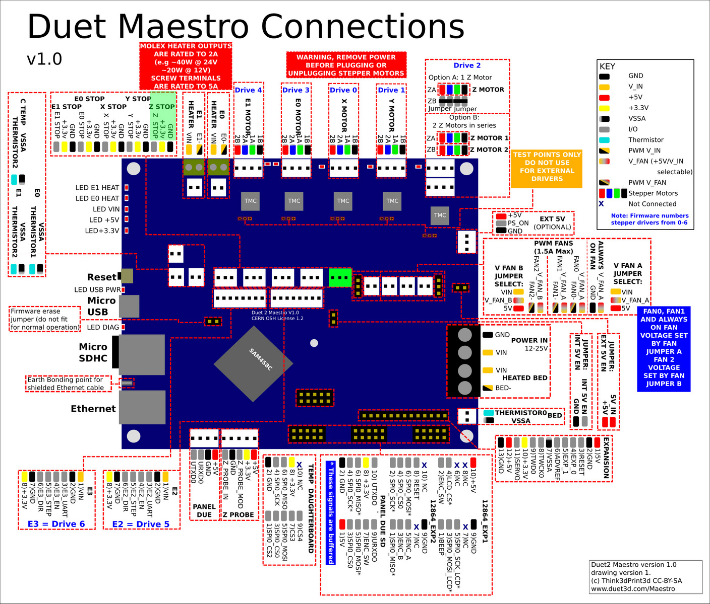

Use another cable tie to tie the cables at the board together like they were before you removed the mechanical switch cable.

## Software Configuration

Next, you need to change the end stop software configuration. This is done in the file machine_endstoptypes.g.

Uncomment the two M574 commands in the optical end stop section and comment the M574 command in the mechanical end stop section.

## Test proper installation

Now lower the bed gently until the fin is just above the probe. Visually check that the fin aligns with the slit in the probe and adjust the fin if necessary. When the fin looks to be in the right place, lower the bed in 1mm steps into the end stop. If that fits without scraping, you’re good to go. If it does scrape, you might want to move the bed up again, readjust the fin or possibly remove it and sand the two sides to make it smooth.

Once the fin fits nicely into the slot, lower the bed until it is about at the bottom. Then restart the printer.

Go into the Web UI, Settings Section, Machine Properties tab. You should see a ‘Yes’ under the Endstop hit column for drive 2, i.e. the Z axis. If that shows as yes, congratulations, you have wired and configured everything correctly. If it shows No, then check the software configuration and the plug once more until it does show as Yes.

You should now be able to home the Z axis. You will have to do the Z end stop calibration again as outlined in machine_zendstop.g

### Appendix A: Printing instructions

The parts were designed to be printed with a 0.5mm nozzle at 0.25mm layer height. They can be printed in PLA or PETG as they are not exposed to excessive heat.

### Appendix B: File List

* Optical Z Endstop Holder.stl
* Main Fin.stl
* Counter Mount.stl